**Metabarcoding Supplement**

To test for taxonomic bias in DNA content, we selected xxx specimens from nine representative taxa (6 Araneae species, from 3 genera and 4 families, and each 1 Orthoptera, Blattodea & Hemiptera species). These specimens represent a wide phylogenetic divergence from very closely related taxa to deeply divergent lineages. Each specimen’s bodylength (head – abdomen for insects, prosoma – opisthosoma for spiders) was measured under a binocular using graph paper and its bodyweight was quantified using a microscale. Each specimen was then extracted in a separate tube and the DNA extraction quantified as described above. The total amount of mg DNA per specimen was calculated.

In order to quantify biases in DNA content between different body parts of arthropods, we analyzed extractions from the prosoma and from legs from two different spider species (*Havaika* sp. and *Pagiopalus* sp.). We compared the ratio of recovered reads and input tissue for the respective body parts in the different mock communities.

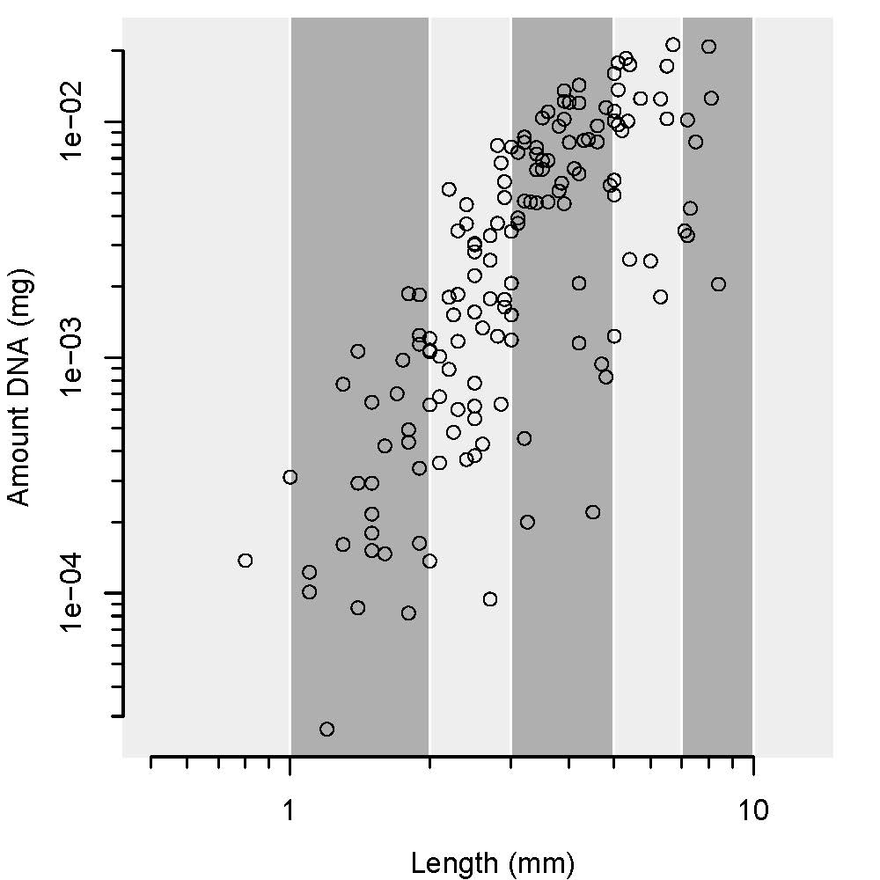

**Supplementary Figure XX Association of A) Body length (mm) to body weight (mg) for 9 exemplary arthropod taxa. B) of body weight and DNA content (mg) and C) of body length (mm) and DNA content (mg) for the same taxa.**

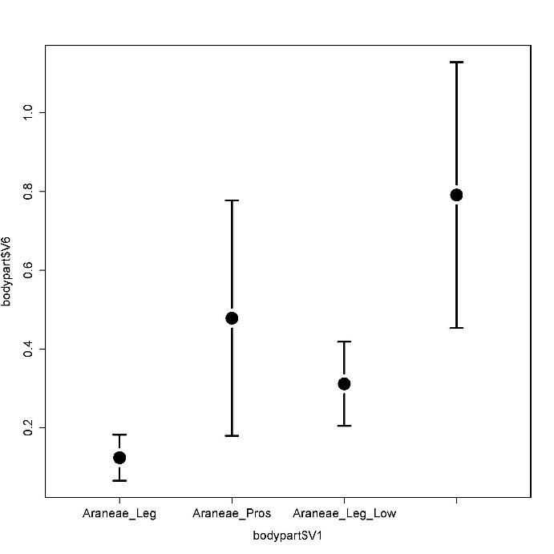

**Supplementary Figure XX Average ratio of the proportion of input tissue for prosoma and legs and recovered mitochondrial COI reads for *Havaika and Pagiopalus* spiders in our tissue pools. The plot shows the average ratios plotted for the high and low molecular weight fraction of the tissue pool DNA.**

An analysis of body length, body weight and corresponding DNA content shows a comparable response for all nine arthropod taxa. Increasing body length is exponentially associated with a gain in body length. The association of DNA content and body length also follows a power law relationship. Specimens of increasing body length yield exponentially increasing DNA amounts. With the exception of Hemipterans, this association is surprisingly similar between spiders, orthopteran and blattodea.

A comparison of the ratios of recovered reads per mg tissue yields very different results for extractions of legs and prosomas from spiders. Extractions from the prosoma recover significantly more DNA per mg tissue than those from the legs. This holds true for both tested spider species. Moreover, a taxonomic bias is clearly visible between high and low molecular weight samples, with low molecular weight samples recovering more spider reads per mg tissue than high molecular weight ones.

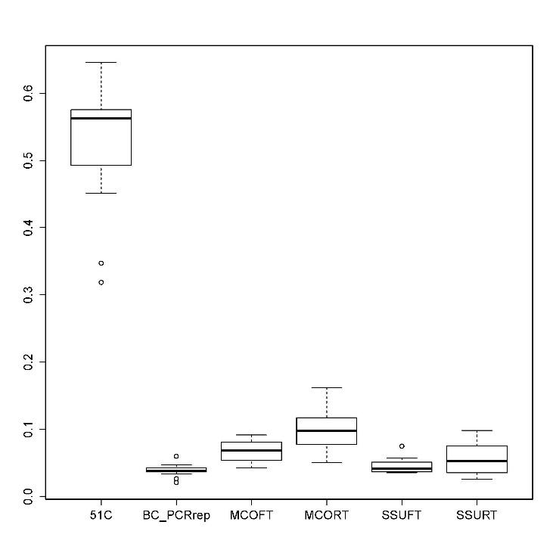

**Supplementary Figure XX Bray Curtis distance between PCR replicates with 5°C different annealing temperature, exact PCR replicates of mock community samples, and high vs. low molecular weight fractions for samples stored under freezer and room temperature conditions.**

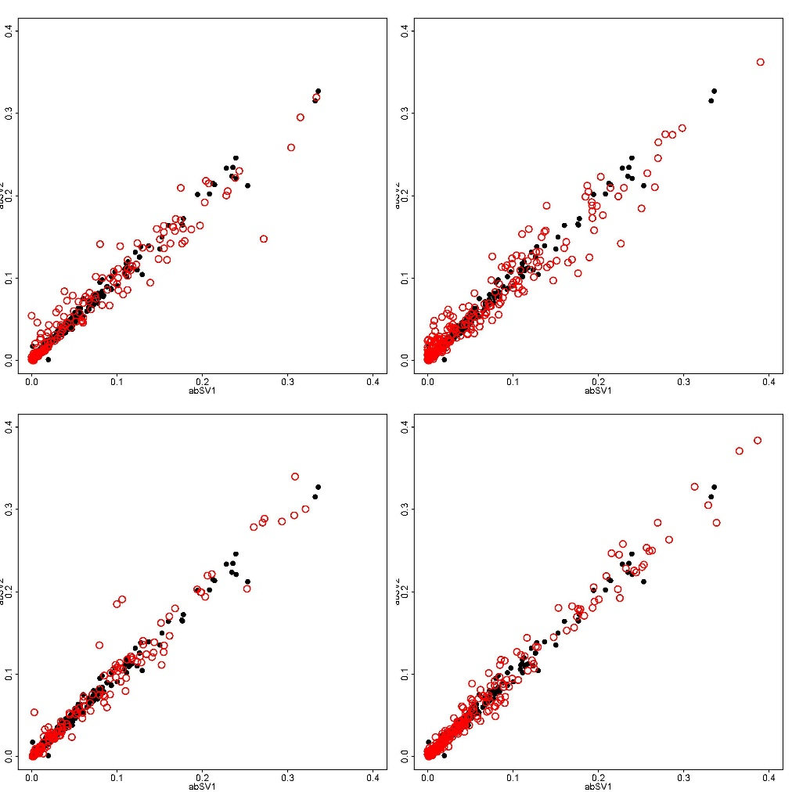

**Supplementary Figure XX A) Association of mitochondrial COI read proportions of from high and low molecular weight samples for all taxa of mock communities stored in the freezer and B) for all samples stored at room temperature C) for the 18srDNA and samples stored in the freezer and D) the 18srDNA and samples stored at room temperature**

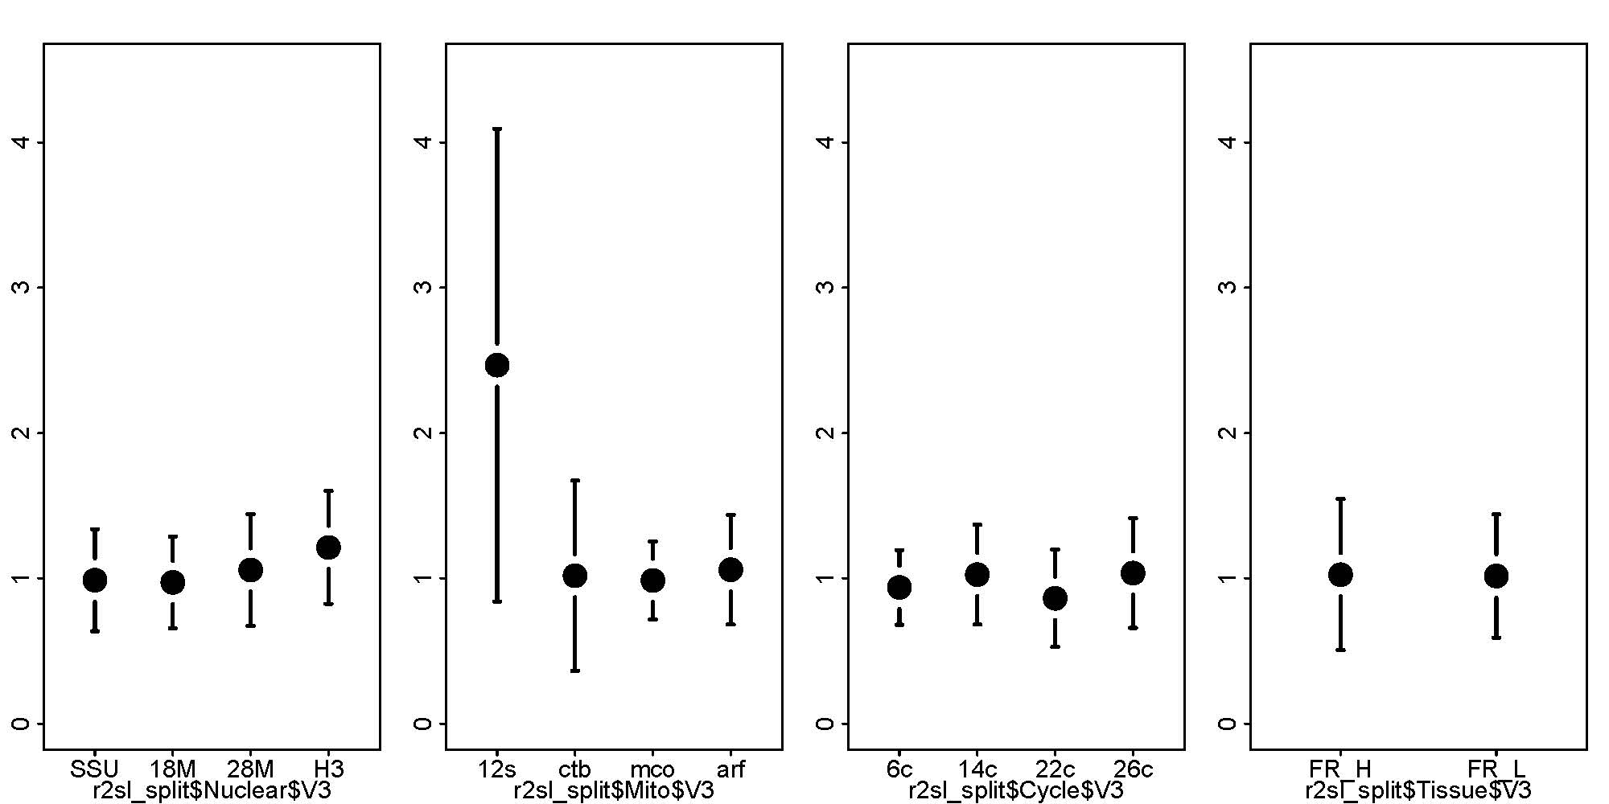

**Supplementary Figure XX Average slope of the association between read count and taxon abundance for A) nuclear markers B) for mitochondrial markers C) for marker ARF with different PCR cycles D) for tissue pools with marker MCO**

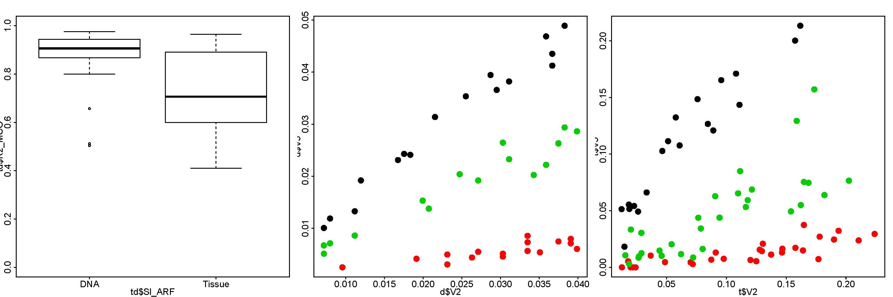

**Supplementary Figure XX A) Association of the proportion of input DNA and recovered reads for three arthropod species (*Porcellio scaber, Proteirulus fuscus, Tomocerus minor*) and B) for the same three species based on tissue pools**